SQL Assignement 3

/*1. write a SQL query to find Employees who have the biggest salary in their Department*/

select Employee.dept_id,Department.dept_name, MAX(salary) AS max_salary from Employee

Inner Join Department

On Employee.dept_id=Department.dept_id

Group By Employee.dept_id ,Department.dept_name

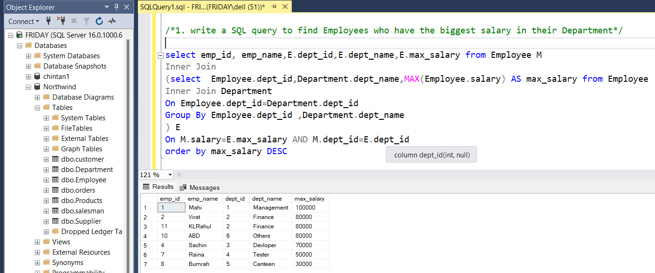

/*2. write a SQL query to find Departments that have less than 3 people in it*/

select Employee.dept_id,Department.dept_name, COUNT(emp_id) as NumberOfEmployee from Employee

Inner Join Department

On Employee.dept_id=Department.dept_id

Group By Employee.dept_id ,Department.dept_name

Having COUNT(emp_id)<3

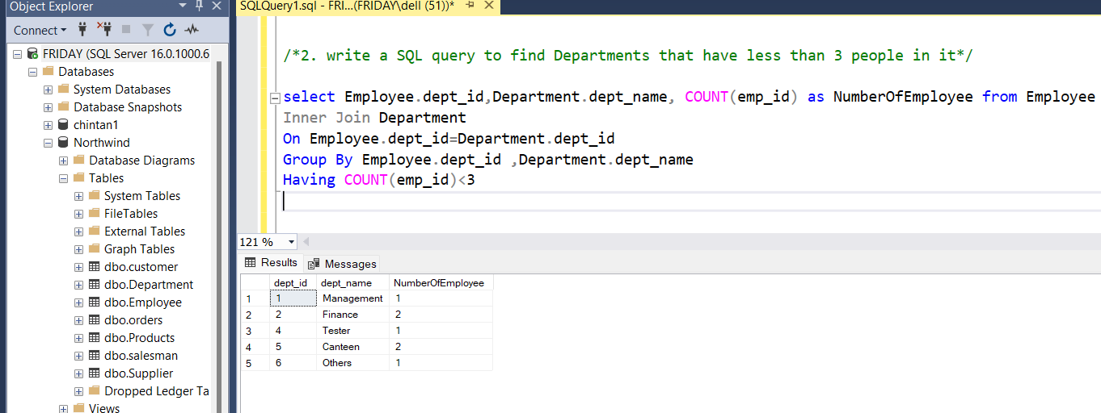

/*3. write a SQL query to find All Department along with the number of people there*/

select Employee.dept_id,Department.dept_name, COUNT(emp_id) as NumberOfEmployee from Employee

Inner Join Department

On Employee.dept_id=Department.dept_id

Group By Employee.dept_id ,Department.dept_name

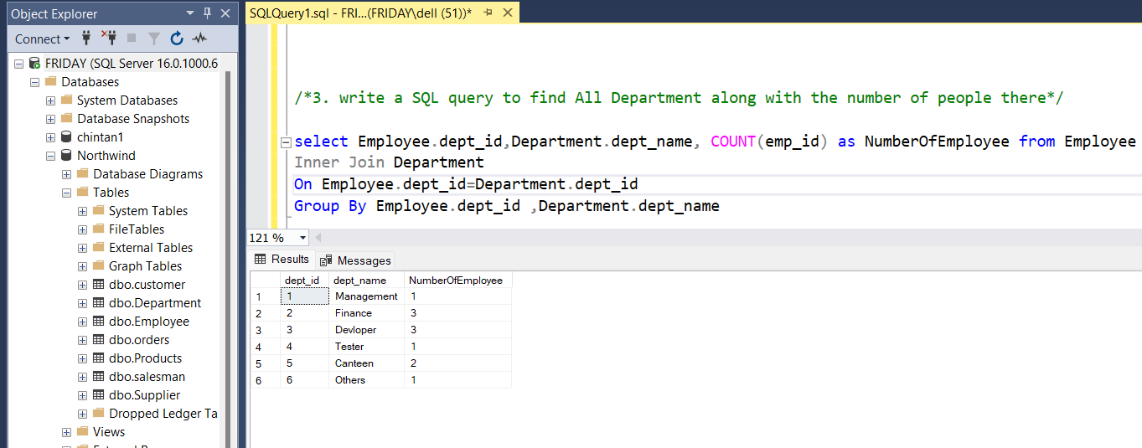

/*4. write a SQL query to find All Department along with the total salary there*/

select Employee.dept_id,Department.dept_name, SUM(salary) AS total_Salary from Employee

Inner Join Department

On Employee.dept_id=Department.dept_id

# Group By Employee.dept_id ,Department.dept_name

